Team Delta GDD

Mete Ruso, Omar Al-Guthmy

Contents

High Level Design 2

Core Gameplay 2

Central Mechanics 2

Low Level Design 2

Player Control 2

Obstacles 3

Environment And Levels 4

Level 1 4

Hub World 6

Aesthetic/Inspiration 6

High Level Design

This will be a methodical, first person, stealth game where you must escort and utilize a box to get past various security measures in a military base. This PC game will be made in a modern setting in a military/bunker setting with close corridors and open rooms.

The core Design Pillars that we will be following are:

* Slow and methodical gameplay.
* Box being an asset and not a burden.
* Clear indicators for relevant information (Camera Line of Sight, Light Levels)

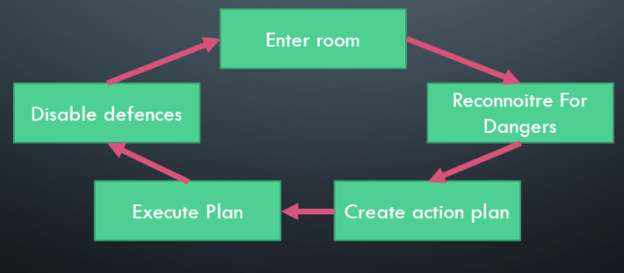A unique selling point of this game is that it is a pure stealth experience that has become increasingly rare in gaming since the fall of the great stealth franchises of Splinter Cell and Metal Gear Solid. Another USP is the unique interactions with the box that can be implemented similar to immersive sim games like the Deus Ex franchise.

Core Gameplay

The core gameplay of this game will be centred around outfoxing security measures in an otherwise deserted military base. The core gameplay loop will entail Scouting for security measures, forming a plan to get around them, executing that plan and deactivating said measures after you have conquered them.

Central Mechanics

The main mechanic that is unique to this game is the box that you will need to get through the level. It can block line of sight for cameras, block light from light sources and can serve as a step up to high ground.

The cameras are the main obstacle. They come in various designs with subtle differences but put simply, they will cause a fail state if they detect the player. There are measures in place to prevent this from being too difficult and hard to understand.

There will be a light level mechanic where you are harder to see in the dark so cameras can be thwarted in that way.

Low Level Design

Player Control

The game will be in first person. The game mechanics include running, jumping, crouching and holding/pickup. First and foremost, the player’s jump would be about 1.5 meters. This would allow the player to jump up the companion box and enable the player to jump over the other end. A good scenario would be when a player needs to jump over the laser grid. This is when the companion box would be of help to the player by jumping up on it then jump across.

Also, the companion box would help the player not get detected by the security cameras to which the player would simply need to crouch and take cover using the companion box. The companion box will block the security camera’s line of sight. In addition to this, the companion box also blocks any light sources. This means that the player would always have to depend on the companion box by picking up and moving with it. In some cases where the player would have to solve puzzles, this would then have the player leave the companion box and finish the task then come back for it. A good example of this would be when a player needs to jump up a higher platform in order to jump to the other side in one of the rooms to which then the player would have the opportunity to deactivate the security cameras when done successfully.

The player would need to be about 1 meter away to be able to interact and pick the companion box. Also, the player would be able to throw/let go of the companion box about 2 meters away from the player.

There will be collectibles in each level that will together unlock a door in the hub world to a power up. It is an Emp gun that shoots a projectile that temporarily shorts out electronics for 5 seconds.

Lastly, the player would have a user interface(UI) light gauge that will show and tell the player whether they are in the dark or not. This will allow the player to quickly react and take cover or simply stay away from any detection when they are not properly hidden.

Obstacles

Since the game consists of no AI, the security cameras with spotlights on them would be one of the obstacles in the game that would slowdown the player and instead encourages the idea of being stealthy to progress in the game successfully but also being careful not to get spotted. There are two variants of the normal cameras which mostly have the same specifications. Some cameras would be infrared and would have a spotlight attached. Cameras with infrared usually act like a night vision camera that can detect players in the dark.

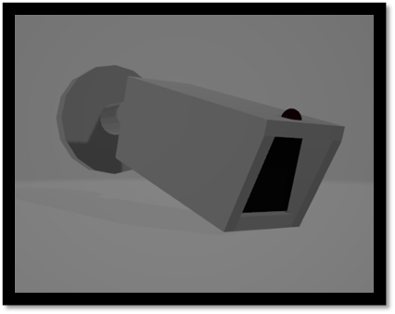

These three types of cameras would be placed in areas of the game where some cameras would be fixed on the wall and swivel by turning right and left. Others would be placed on rails that would make the camera move along a fixed path. This idea of camera iteration gives the player some sort of different challenges that they have to face.

However, the player will be able to deactivate the cameras by interacting with the circuit box and turning them off.

Also, one of the other obstacles are the laser grids that prevent and block the player from directly walking aimlessly but instead forced to follow a path or change the way of approaching a path that they would have to go to in certain areas where the laser grids are.

In addition to this, another obstacle that a player might face are traps that are placed in some sections of the level that prevents the player from passing through but instead have to find other ways of passing through that area. Areas that have pit traps are in places where the laser grinds are placed. This helps give the player an idea of using a different approach method that they would have to use to progress throughout the game level.

Environment And Levels

Level 1

We have one level blueprint. The player will start on the left side of the map and end on the right side of the map. The only way to end the level is by opening the door with the box. There is an optional collectible in the warehouse using a key found in the reception

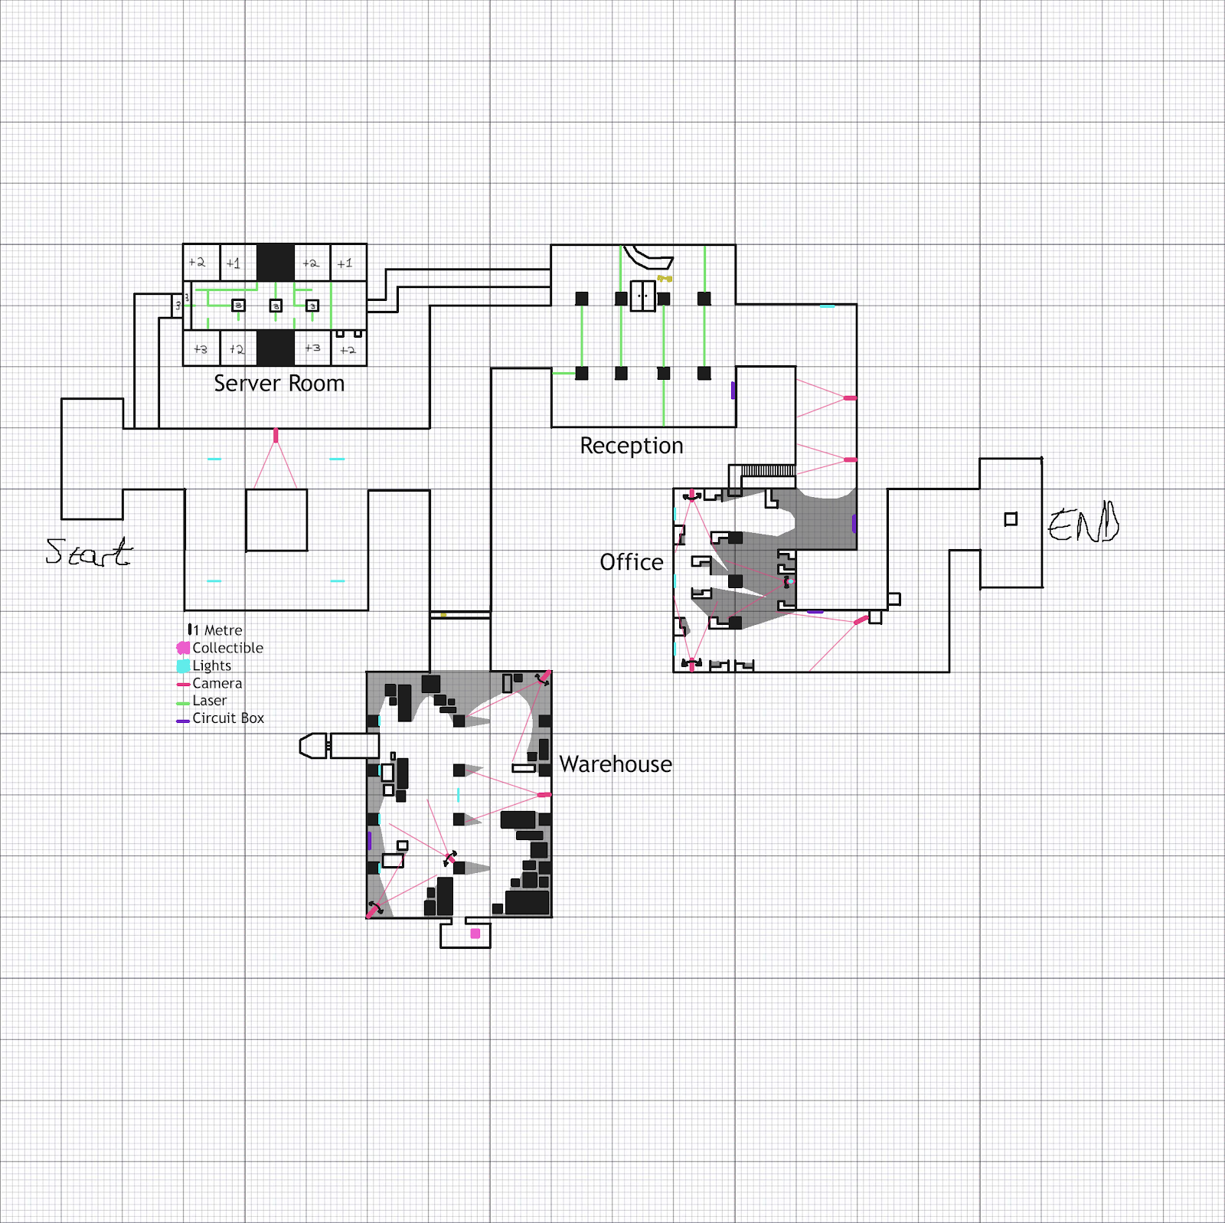

Walkthrough

The first corridor that leads to the reception teaches the player that cameras are the obstacles and offers an easy solution to walk around it.

Reception

A small laser grid maze stops the player from moving freely. There is a pitfall trap halfway through that kicks the player into the server room. There are two ways to get around this. One is to jump on the box which gives you enough height to clear the gap made by the pitfall. The second solution is to find a low laser and use the box to jump over it. The player can turn off the security measures using the circuit box and pick up the key to the warehouse.

Server Room

If the player “falls” for the pitfall trap they will be stuck in a vent that leads to the server room. This has more laser grids that the player has to avoid. This room is designed to be completed without the box just in case they dropped down without it. There are two ways to complete the room. The first requires the box. The player can jump on the box to reach the left platforms and jump from pillar to pillar to skip the second laser maze. The right path does not require to box and the player needs to navigate the maze.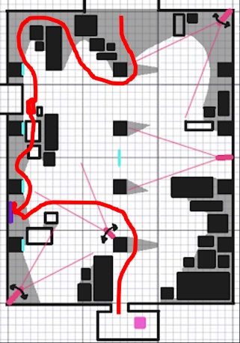

Warehouse

The warehouse can only be accessed with the reception key. The player will have to take a winding path around the room to reach the end. They would have to wait for camera swivels while sticking to shadows before leaving behind the box to vault over some storage crates to find the circuit box. The path is drawn out in the diagram of the room. This is an optional room that leads to one piece of the collectible lock.

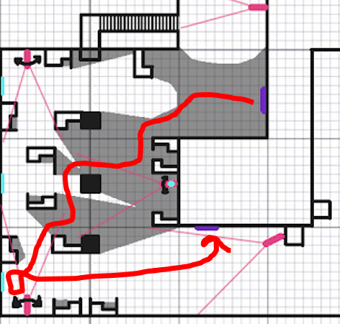Office

The office is the last room in the level. The main obstacles in this room are the two side cameras and the middle camera that has a spotlight on it. There is a small staircase before this room which lets the player get a safe birds eye view of the room so that they can plan.

The main objective is to get to the circuit box but there is a static camera pointed right at it. The solution is to leave the box to block the light source at the bottom left corner so you can move freely in the space. Your only obstacle to avoid is the spotlight camera but it would be easy to time a safe passage to the circuit box

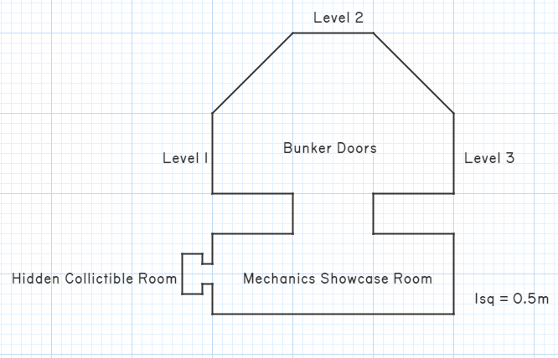

Hub World

The hub world is where the player can select levels. There are three rooms. The first with labeled doors to levels, the second is a room where the player can inspect the various obstacles in a safe environment, and the third being locked and housing the Emp Gun

Aesthetic/Inspiration

The environment will be a modern/military setting with cold concrete and steel being the main materials. The room at the bottom is themed to be a warehouse with many storage crates and a truck delivering them. It is themed off of a screenshot from Splinter Cell Blacklist

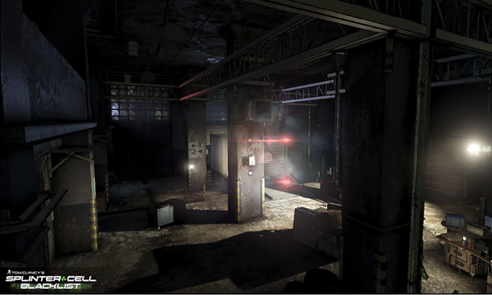

The room at the top middle is themed to be a reception with a large desk where the key to the warehouse will be.

The penultimate room on the right side, will be themed as an office with desks and cover and a small room overlooking the workers. The main inspiration was the CIA headquarters level of the original Splinter Cell.

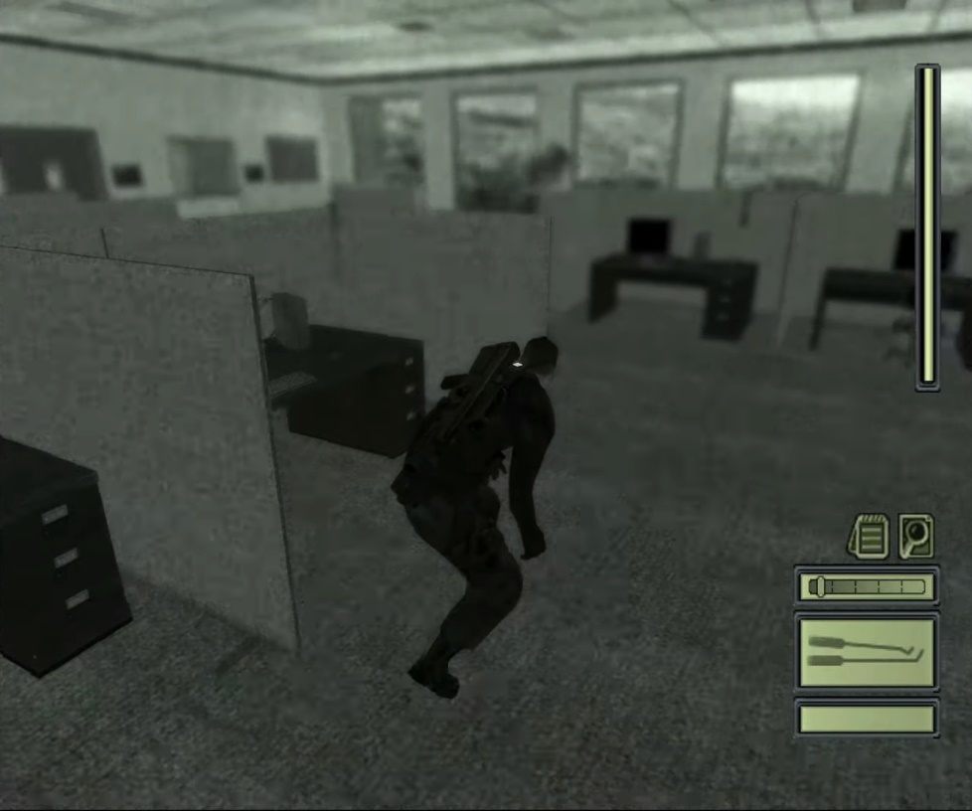

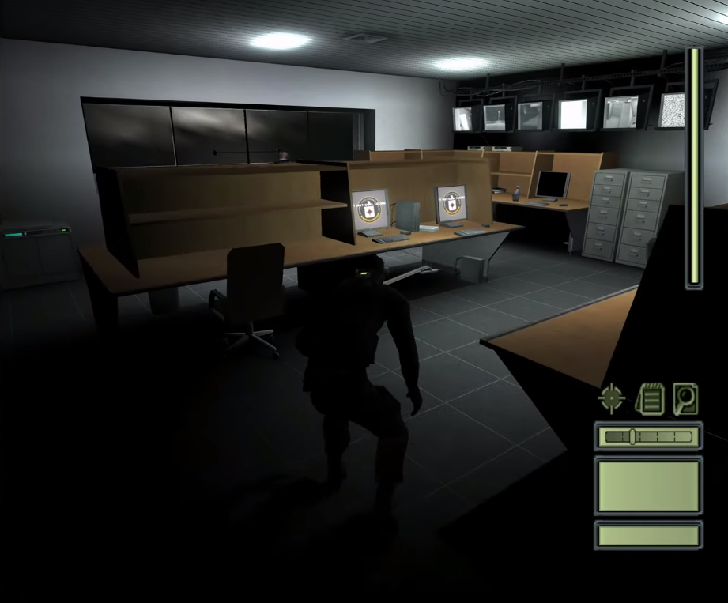

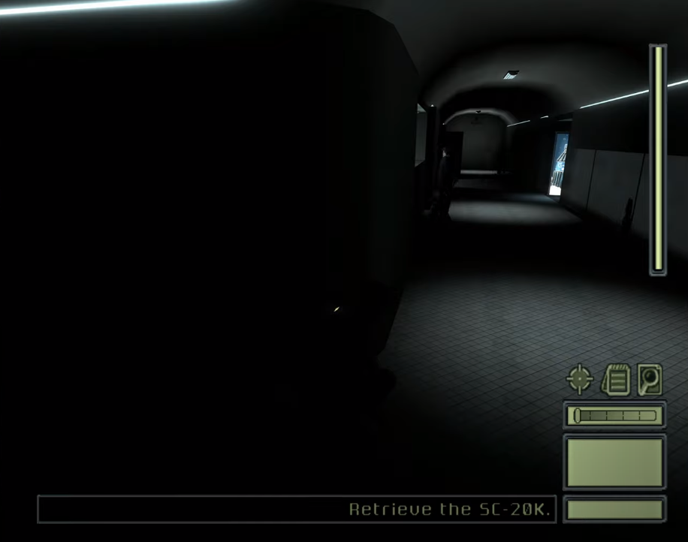

The Emp Gun is also based off the SC Pistol in Splinter cell which has an alternate fire that can disable electronics.

